بسم الله الرحمن الرحيم

الاجازة فى الاكسيس
ICDL

تجميع المادة العلمية
تم بواسطة
محمد احمد المصيلحى

للتواصل معى : MOSELHY86@yahoo.com
ت : 0127241040

Database

Sales Catalogue

Not a Database

Student Register

Novel

Shopping list
Customer records

2. Which one of the following is not a Database.
 A telephone Directory.
 A sales Catalogue.
· A newsletter.
 A price list.

Table
- Navigate quickly to the last record in this table  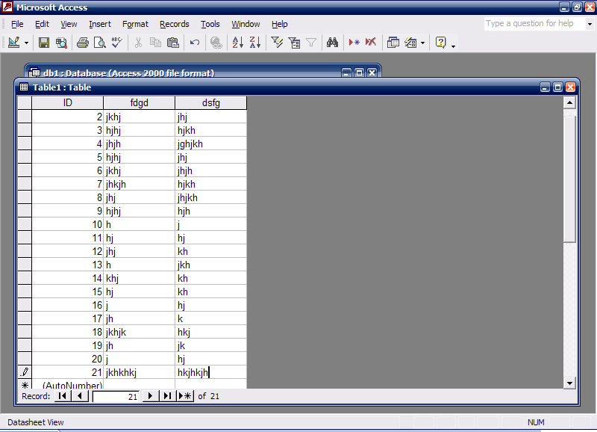 نضغط على

- Save and close this table  file save file close

- Access the option that would enable you to create a new table without the help of wizard  table نضغط على D.click on create table in design view

- Switch to design view  view design view  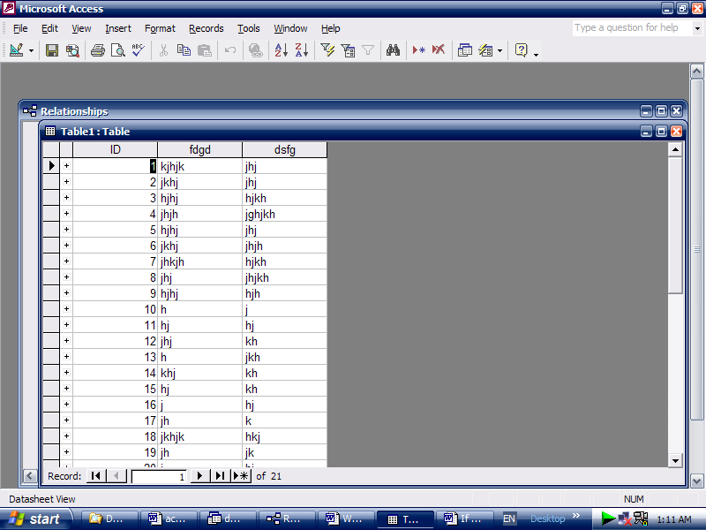

- Create a new table in design view .  Click on table D.click on create table in design view

- A business , Coffee Galore , has moved premises. Please delete the selected field value Camber well Lane , from its record.  فى لوحة المفاتيح delete نضغط على
- Make the most appropriate field the primary key for this table.  Patient ID نضغط على الجزء الرمادى بجوار حقل ⇨ فى شريط الأدوات 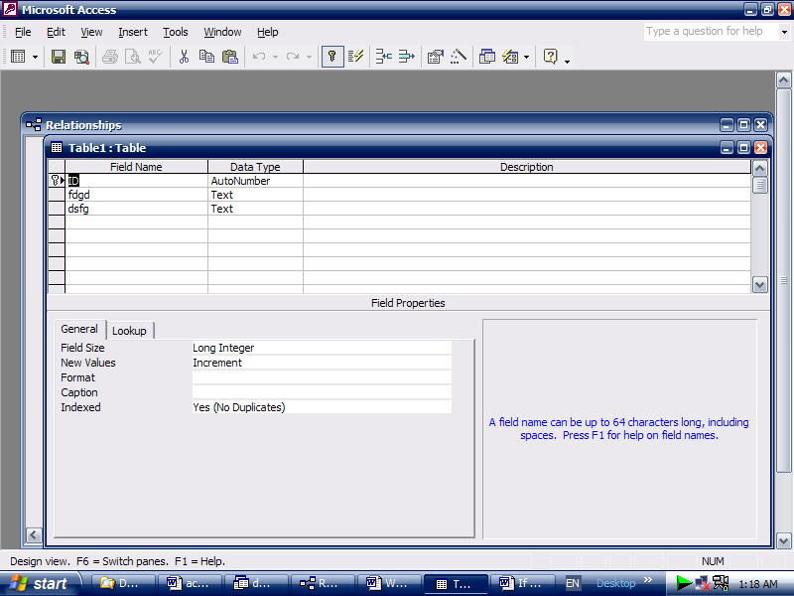 نضغط على  Patient ID نضغط على الجزء الرمادى بجوار حقل R.click Primary Key

- Using click and drag, move the selected column to between the date of birth and Doctor ID fields  نقف فى أعلى العمود فى الجزء الرمادى نسحب حتى يظهر خط بين الحقلين المطلوبين ثم نترك الفارة

- Print 1 copy of the First 5 records in this table using the default printer. Note : this is simulation and the datasheet will not really be printed.  نحدد الخمس صفوف الأولى فى الجدولبالسحب من خلال الجزء الرمادى File ⇨print ⇨ selected records ⇨ok

- Which data type is most appropriate for a postal code field such as M45WT?  Number  Text  Date/Time  Auto number

- Save this database as a Books into the My Documents folder.  هنا ستكون المربع الحوارى الخاص بالحفظ مفتوح My Documents نختار ⇨ file name: book نكتب ⇨ create .

- Close the Northwest Division database without closing Microsoft Access.  File ⇨ Close.

- Add an empty field above the First name field in this table.  first name نضع المؤشر فى حقل ⇨Insert ⇨rows .

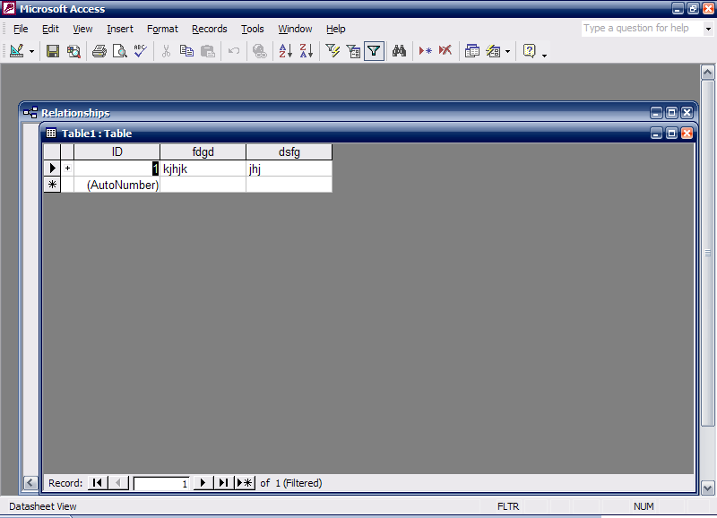
- Navigate directly to record 25 in this table.  25 → enter.

- Sort these records so that authors with surnames beginning with A would display at the top of the datasheet.  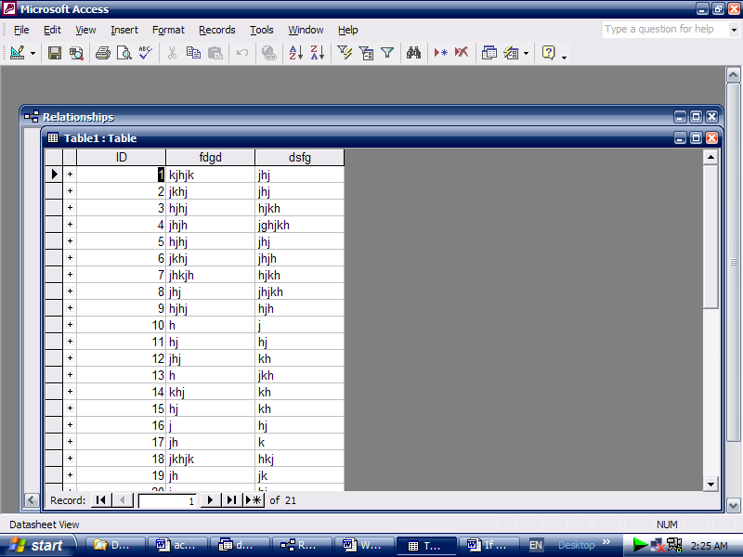

- Select the data type that will automatically assign a unique Customer ID number to each new customer. Move to the next cell when you have finished.  data type نضع المؤشر فى عمود ⇨تظهر قائمة منسدلة لأسفل Auto number نختار ⇨ فى لوحة المفاتيح tab نضغط على

- Navigate quickly to the last record in this table  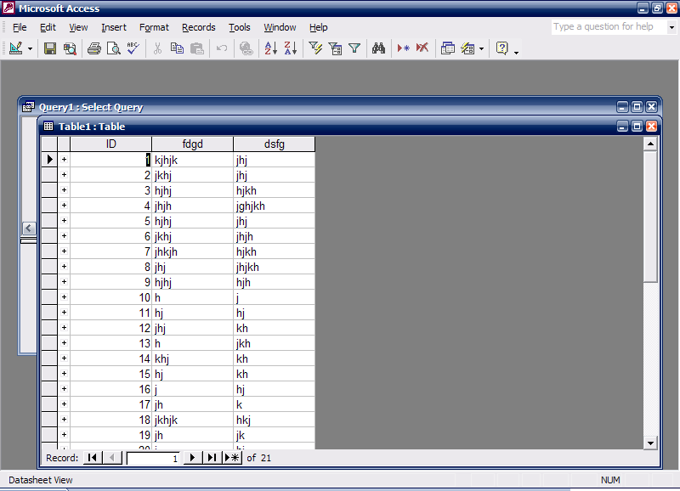

- How many fields would be necessary to store this record and enable maximum flexibility for data retrieval. Mr. Alan Baker, 21 Liverpool Road, Manchester M54WT.   6 نكتب
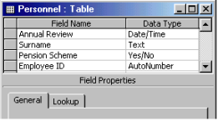
- Which of this fields would be best suited to use at the primary key for this table ?  employee ID نضغط على الجزء الرمادى عند حقل

- Log on the database named car hire with the username icoffey and password Ken*72  car hire نختار من الجانب الأيمن ⇨ يظهر مربع ⇨ name: icoffeyنكتب ⇨ password: ken*72نكتب ok

- create a new blank database.  file new blank database

- The surname field will be used in a lot of searches, so we should index it. Create a suitable index for this field.  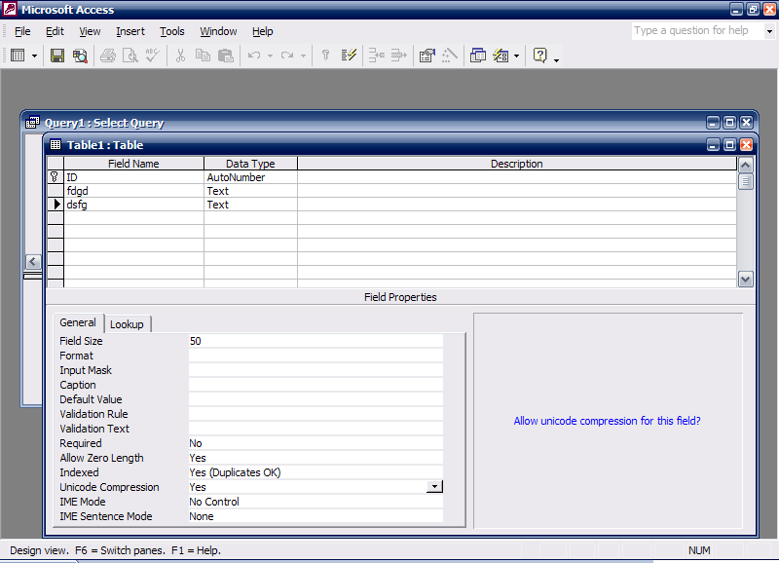

- Use Microsoft Access Help to find information about decimal numbers  Help ⇨Microsoft access help ⇨ decimal numbers نكتب ⇨search

- Save the above table and give it the name Sales .  file save ⇨ Salesنكتب ⇨ok

- Enter the field name Contact Name into the empty row. When you have finished ,move the insertion point to the Date type column .  فى الصف الفارغ Contact Name نكتب ⇨ فى لوحة المفاتيح Tab نضغط على

- Change the entry in the Surname field of this record to Dawson. Move the next field in this record when you have finished.  Surname نمسح الكلمة الموجودة فى حقل ⇨ Dawson نكتب ⇨ Tab نضفط على

- The surname field will be used in a lot of searches, so we should index it.
Create a suitable index for this field  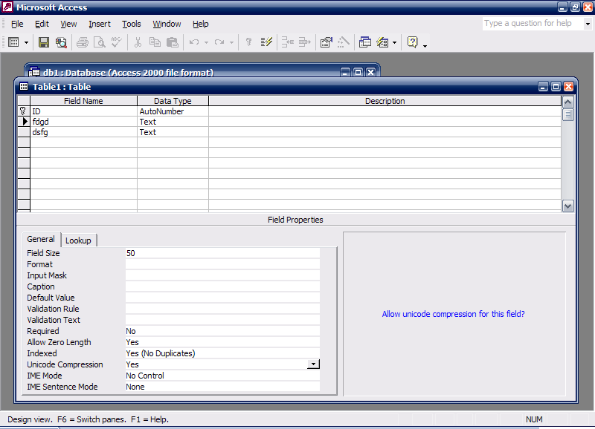

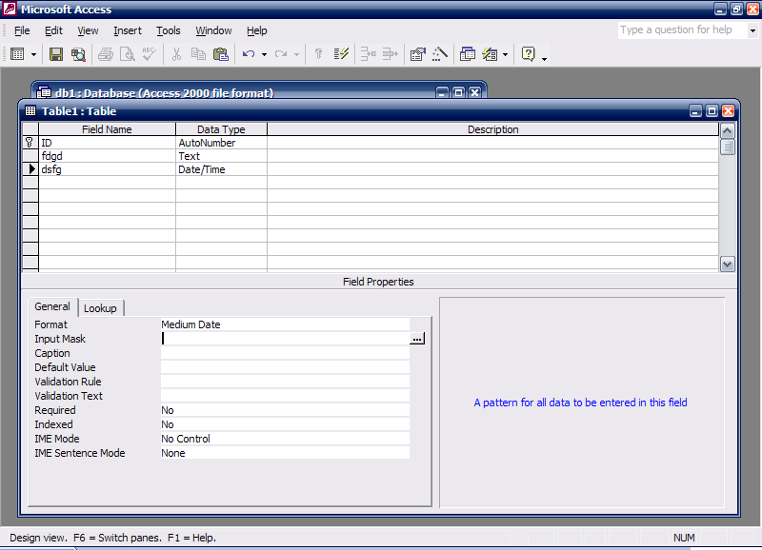
- Specify that dates of birth in this table display in the format 12- November- 2000  date of birth نضع المؤشر فى حقل باسم

- Enter a validation rule to ensure that entries into this field must be numbers greater than 10. press Enter when you have finished  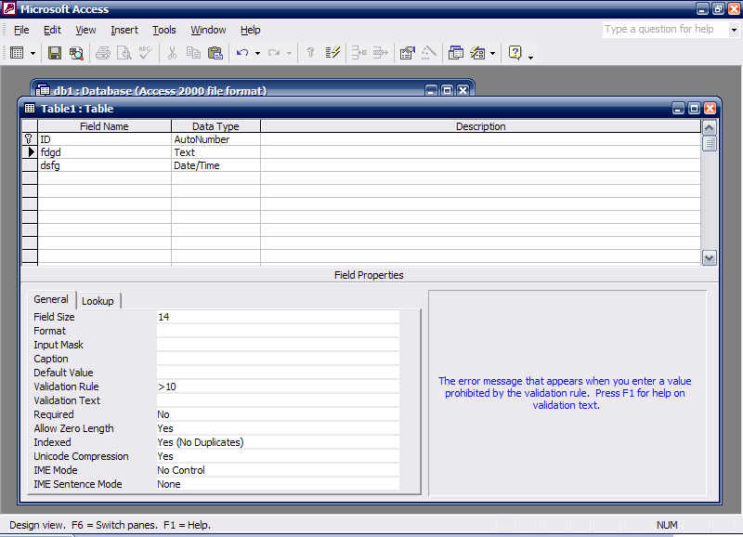 Enter

- Use the search tools provided by access to find the book with the unique (ISBN) code 3546-1236-7  Edit find find what: نكتب 3546-1236-7 find next

- Use filter by selection to filter the records of all employees whose first name begins with S  first name فى حقل ال فى بداية الكلمة S نحدد حرف 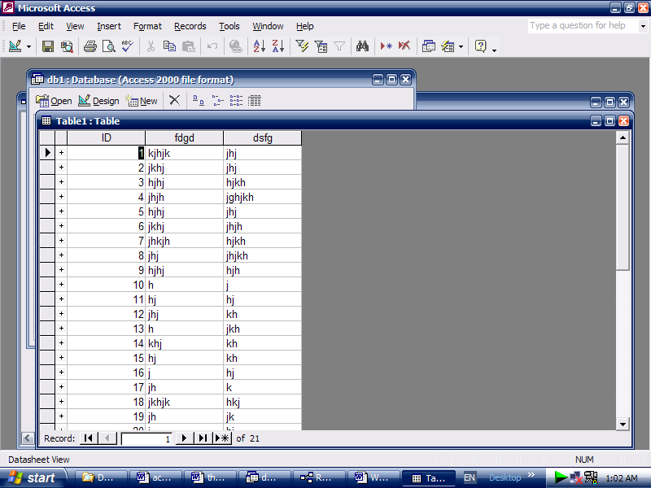

- A filter by selection has been applied to this table. Remove the filter.  فى شريط الأدوات 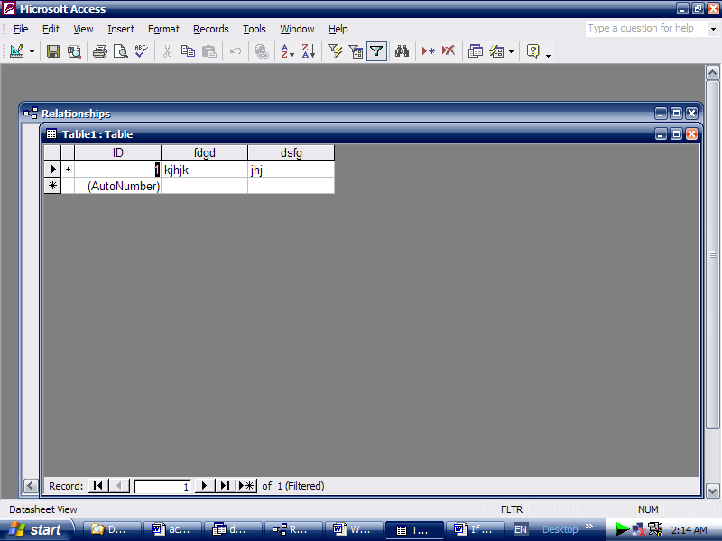 نضغط على

- Enter a validation rule to ensure entries into this field must be either the words Full-time or Part-time. Press Enter when you have finished.  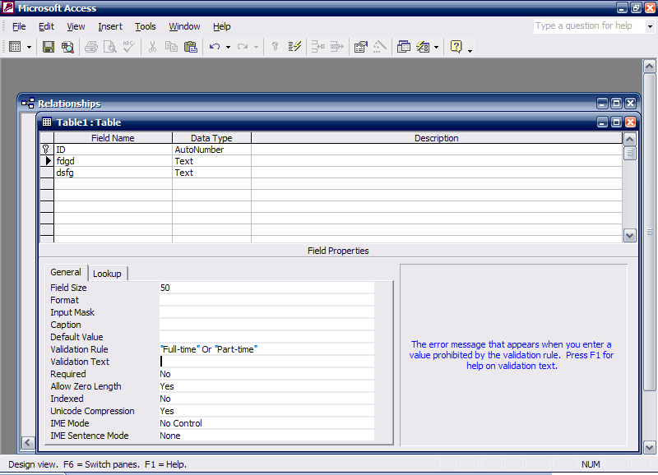⇨ enter.

- Carry out the necessary steps to ensure that you can enter half-days in the Days leave field.  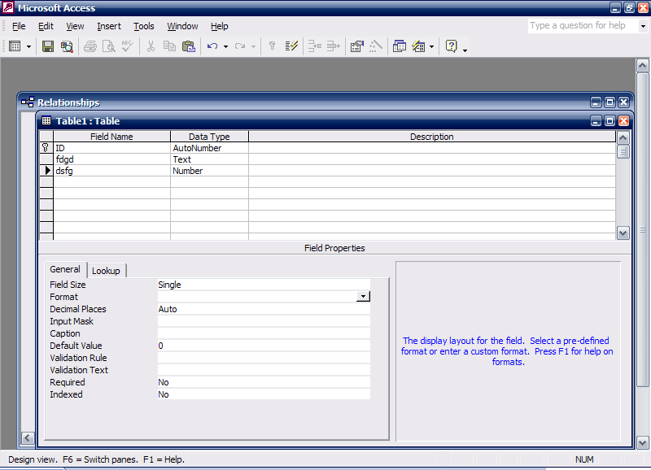

- The Product code field contains a unique reference for each product. This field will be used in a lot of searches, so we should index it. Create a suitable index for this field.  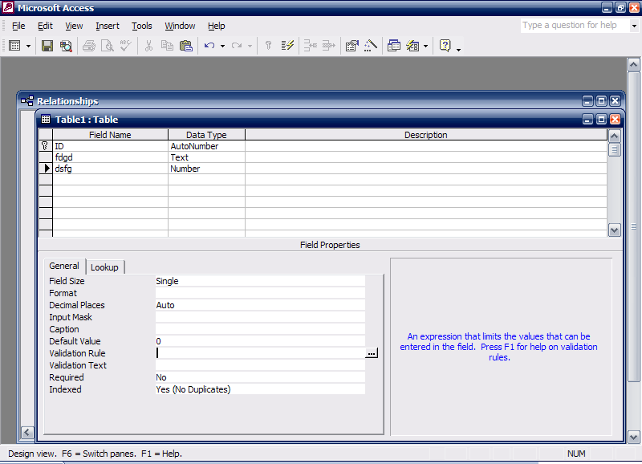

- Each author has written a number of books. Setup a one-to-many relationship between the book and author tables  tool Relationship سيظهر مربع نختار منه أسماء الجداول Author نختار Add Book نختار Add فى الجدول الآخر Author ID إلى Author ID نسحب من كالتالى :-
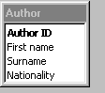
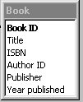

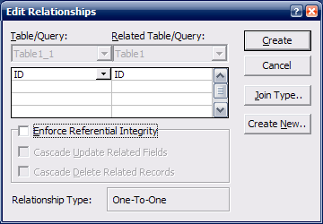
- The payment table contains billing details for each patient. Edit the relationship between the payment and patient tables to prevent who has made a payment from being deleted  R.click on العلاقة Edit relationship  ok

- Delete the one-to-many relationship between the patient and payment tables  R.click on خط العلاقة delete yes

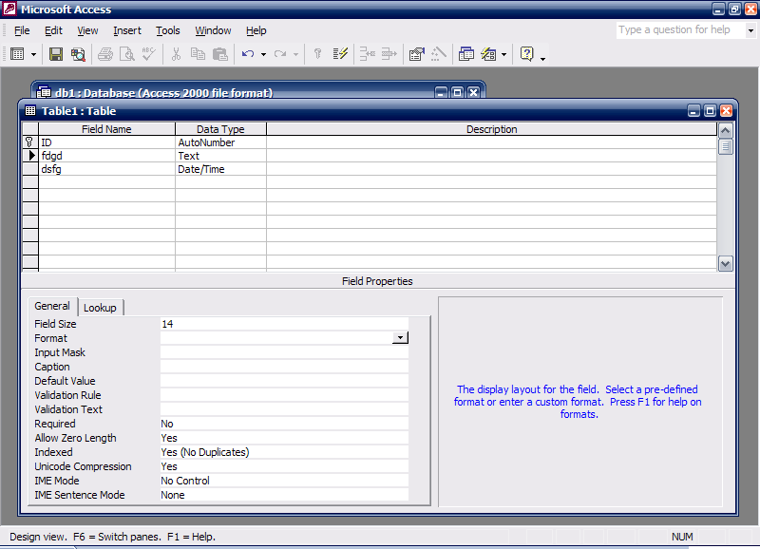
- Which one of the following statements about setting the field size property in a table is True?  If you change the Stock Ref. field size property to 15 existing data will not change.

- Which two of the following statement about indexed are true?  You can index any field no matter what its data type is.  indexing is especially useful when working with large tables  you should index a field that is frequently sorted.

- Which two of these statements about relation databases are true?
- A non-relational database can be searched more efficiently than a relational database.
· A relational database is easier to maintain than a non-relational one.
- In relational databases the need for data duplication is increased.
- Smaller linker linked tables are harder to mange than on big one.
· A relational database is one that contains linked tables.

40 - Which two of the following statements are true?
< 100 will find values that are greater than 100.
>= 10 will find values that are greater than or equal to 10.
 >=Sep 30 1950 will find dates that are equal to or before Sep 30th 1950.
 <=Oct 31 1956 will find dates that are equal to or after Oct 31st 1956.
<Jan 1 1965 AND > Dec 31 1963 will find all dates in 1984.

41 - which two of these statements about referntial integrity are true?
· if a record in a parent table has a related child record , referntial intergrity prevents you from deleting the parent record.
 in Access , referential integrity is enforced by typing in a rule.
 You can set rules about referential integrity in one a table database.
 Referential integrity ensures that records in linked tables are automatically updated when changes are made.
· A child record cannot be entered unless it has a parent in the database if referential integrity is used.

Query

- Add the appropriate field from the Employee table to the 3rd column of the grid so that this query will be able to sort employee records according to their age.  نضع المؤشر فى العمود الثالث سيظهر قائمة منسدلة لأسفل نختار منها Birth date

- Make the Stock and Customer tables the record source for this Query. Close the show table dialog box to complete the exercise.  Customer نختار ⇨ add ⇨ stock نختار ⇨ add ⇨ close .
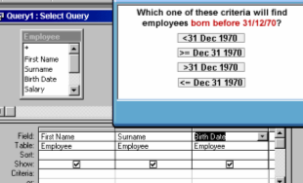
-  نضغط على <31 Dec 1970 ونسحبها إلى منطقة Criteria

- Create a new query using the Simple Query Wizard.  Queries نختار ⇨dزclick on create query by using wizard .

- Access the option that would enable you to create a new query without the help of Wizard .  query نضغط على ⇨d.click on create query in Design view

- Create A New Query Using the simple query Wizard ?  query نضغط على D.click on create query by using wizard

- Save the above query and give it the name Employee Salaries .  file save ⇨ Employee Salaries نكتب ⇨ok

- Find all payments made on or after 06/06/2002. Press Enter when are finished.  payment date فى عمود ⇨ criteria فى ⇨ >= 06/06/2002 نكتب ⇨ enter

- We no longer need the query, Books by Americans Delete this query now.  R.click on Books by Americans ⇨فى لوحة المفاتيح Delete ⇨ yes

- Change this query so that it will just find books by Spanish authors , and then run this query.  view design view Nationality من عمود Russian و or نحذف كلمة فى لوحة المفاتيح 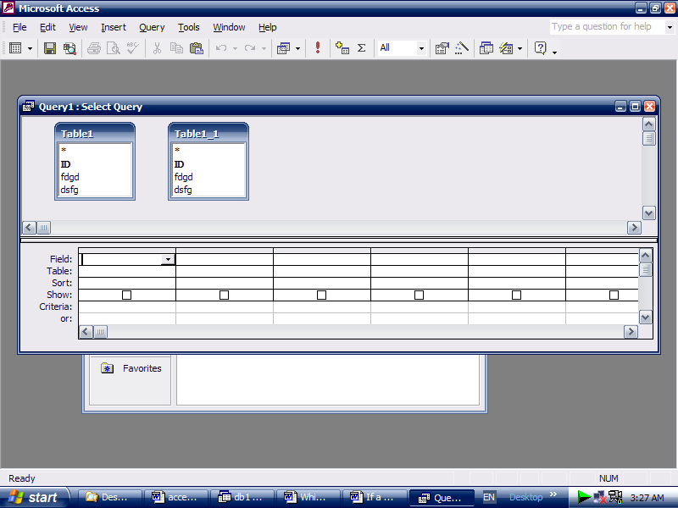 نضغط على

- Sort this query so that the most recent payment display at the top of datasheet.  payment date نضع المؤشر فى حقل ⇨ فى شريط الأدوات 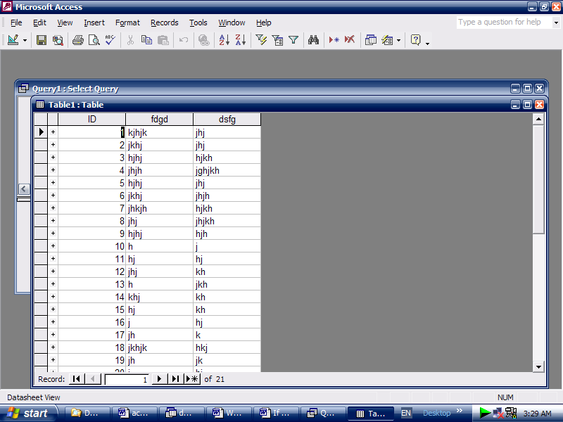 نضغط على

- This query shows all patients born before 1962. Change it so that the date of birth will not be visible in the query results.  R.click on date of birth عمود hide column

Form
- Hide the Formatting ( Form/Report ) toolbar.  View ⇨toolbars ⇨ formatting (form/Report)

- Alter the header text to Patient details and press the Enter key when you have finished.  header موجود فى Patient نضغط على مربع به كلمة details نكتب كلمة ⇨ enter نضغط

- Access the option that would enable you to create a new form without the help of Wizard .  forms نختار ⇨ d.click on create form in Design view

- The book in record 5 is no longer available . delete this record from data base.  فى شريط الأدوات 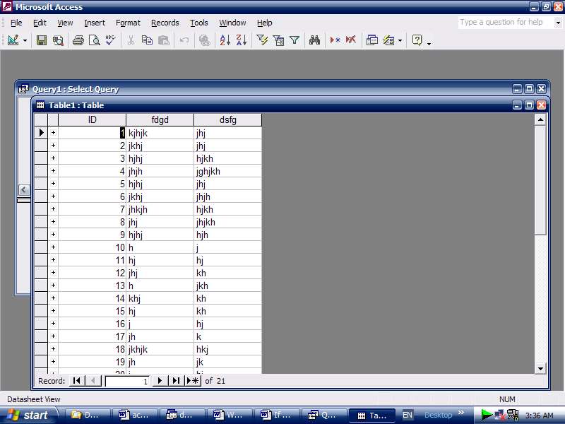 نضغط على ⇨yes

- Delete the text box Class from this form . Save the changes without close the form.  class نحدد المربع الرمادى الذى به كلمة ⇨فى لوحة المفاتيح delete نضغط ⇨file save .

- Navigate to the next record in this form.  نضغط على

- print pages 4 to 6 in this form , using the current print settings. Note: this is simulation and the form will not really be printed.  File ⇨print ⇨ 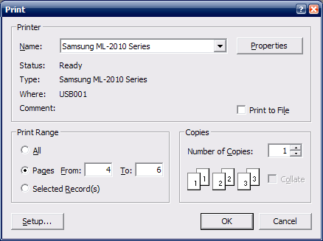 ⇨ ok .

Report

- Delete the control for the data from this report.  نحدد من لوحة المفاتيح delete نضغط

- open the payments by patient report in the print preview.  report نختار R.click on payments by patient ⇨ print preview

- 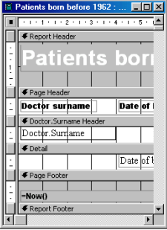Which two of the following statements about the layout of the data fields and headers are true ?
You can change the layout of a report in design view
The order in which you add fields in the
Wizard sets how they display in the report.
 If you move a page Header control, the
associated Detail control will move with it.
 You can change the layout of a report in
printer Preview.
 You can rearrange the order of fields in report
using the sorting and Grouping dialog box.

69-

Database

Sales Catalogue

Not a Database

Student Register

Novel

Shopping list
Customer records
70- Which two of the following statements are true?
< 100 will find values that are greater than 100.
>= 10 will find values that are greater than or equal to 10.
 >=Sep 30 1950 will find dates that are equal to or before Sep 30th 1950.
 <=Oct 31 1956 will find dates that are equal to or after Oct 31st 1956.
<Jan 1 1965 AND > Dec 31 1963 will find all dates in 1984.

71- Select the data type that will automatically assign a unique Customer ID number to each new customer.
Move to the next cell when you have finished.
In the data type column ⇨use the drop down list and select Auto number ⇨press tab from the keyboard .

72- The Product code field contains a unique reference for each product.
This field will be used in a lot of searches, so we should index it.
Create a suitable index for this field.
Put the cursor in the indexed box ⇨from the drop down list select yes (No Duplicates)

73- Create a new query using the Simple Query Wizard.

Select Queries from the object pane ⇨double click on create query by using wizard .

74- Which one of the following is not a Database.
 A telephone Directory.
 A sales Catalogue.
· A newsletter.
 A price list.

75- Which two of the following statements about the layout of the data fields and headers are true ?
You can change the layout of a report in
The order in which you add fields in the
Wizard sets how they display in the report.
 If you move a page Header control, the
associated Detail control will move with it.
 You can change the layout of a report in
printer Preview.
 You can rearrange the order of fields in report
using the sorting and Grouping dialog box.

