شرح اعدادات مودم افاق DSL شامل الجديد ـ 007 بالصور

This image has been resized. Click this bar to view the full image. The original image is sized 714x444 and weights 20KB.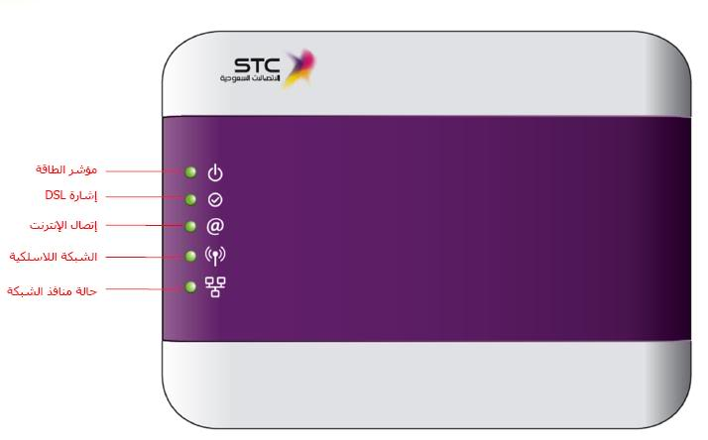

IP Address = 192.168.1.1

This image has been resized. Click this bar to view the full image. The original image is sized 1024x404 and weights 41KB.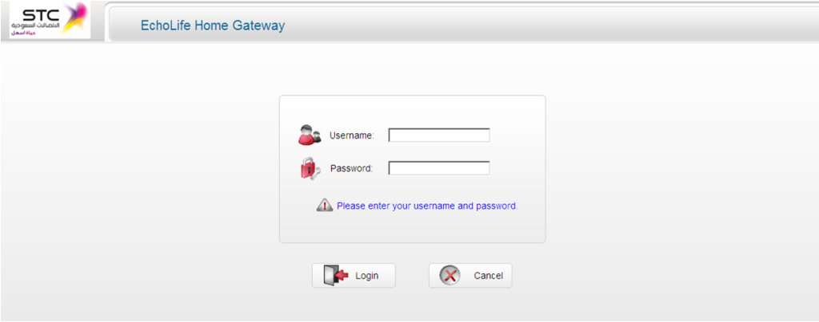

User Name = Afaq_Shamel

Password = Stccpe_2009

This image has been resized. Click this bar to view the full image. The original image is sized 1023x402 and weights 43KB.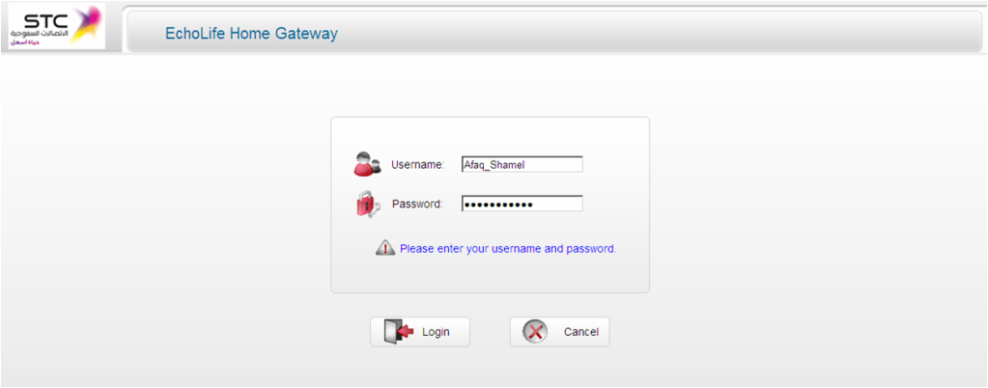

Status :

This image has been resized. Click this bar to view the full image. The original image is sized 1023x297 and weights 75KB.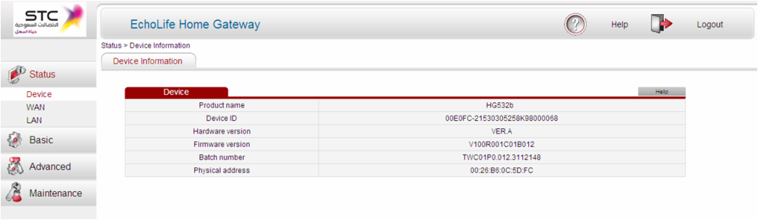

Basic (Type the user name & Password) for AfaqShamel

This image has been resized. Click this bar to view the full image. The original image is sized 1023x552 and weights 133KB.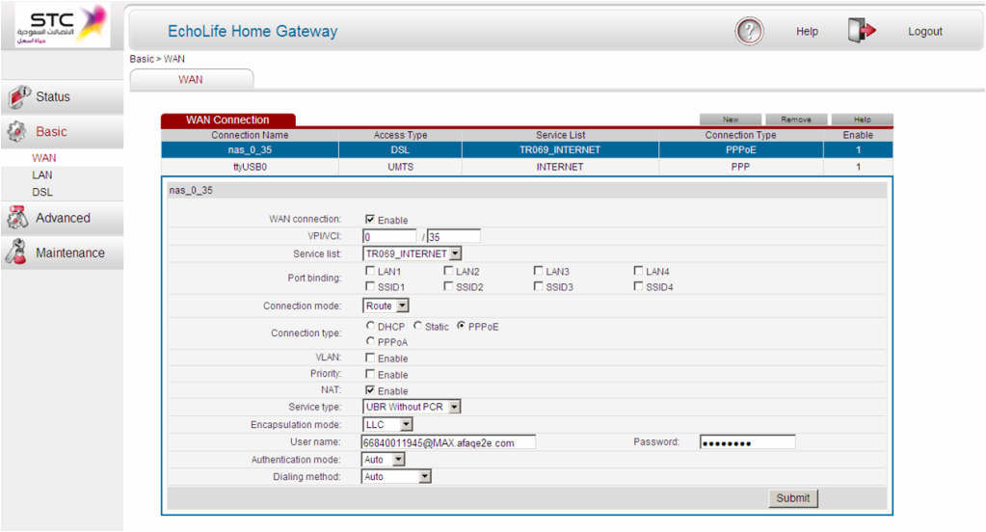

LAN – WLAN (selection for Wireless Key)

This image has been resized. Click this bar to view the full image. The original image is sized 1022x504 and weights 106KB.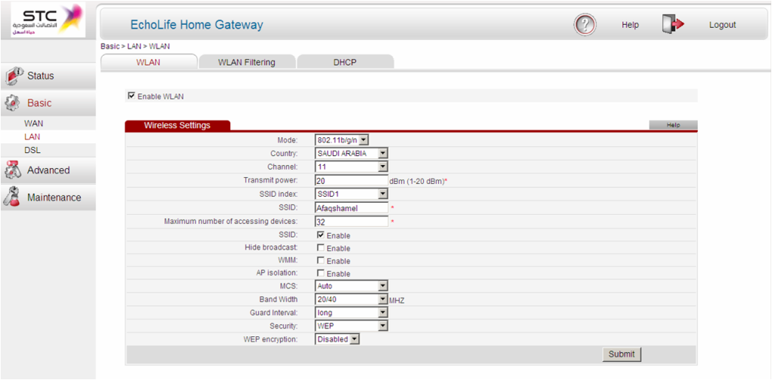

Security = WPA-PSK Encryption = TKIP

This image has been resized. Click this bar to view the full image. The original image is sized 1024x553 and weights 118KB.