بسم الله و الصلاة و السلام على رسول الله صلى الله عليه و سلم

كيف ترسم مكعب متحرك على نموذج بدون استخدام مكتبة OpenGl

قم بفتح الفيجوال ستديو

انشىء مشروع جديد نوعه
Windows Form

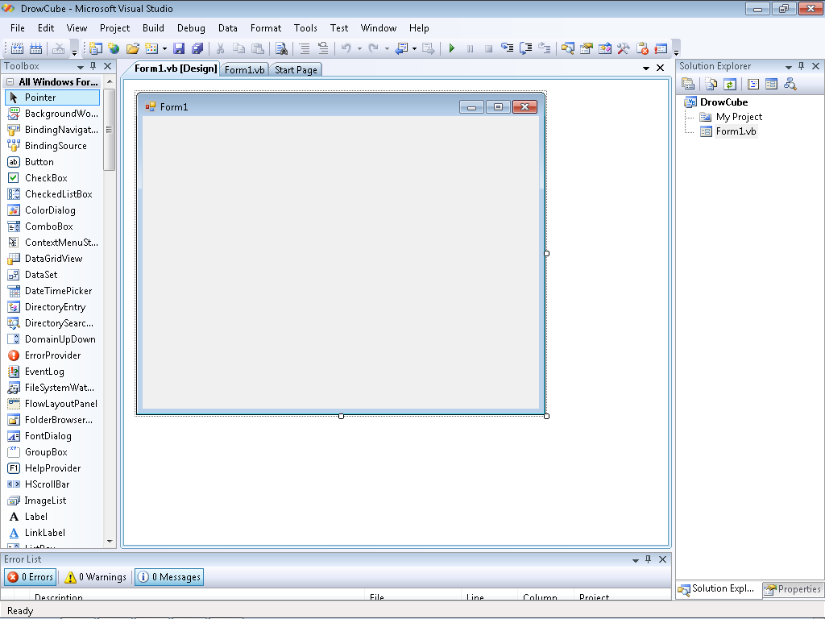

قم بالنقر المزدوج على النموذج ليظهر لك صفحة الكود

قم بعد ذلك بمسح جميع ما فى صفحة الكود ثم انسخ الكود التالى مباشرة بدون اى تعديل

Option Explicit On

' ترجمان عربى
Imports System.Drawing.Graphics
Imports System.Drawing.Pen
Imports System.Drawing.Color
Imports System.Drawing.Brush
Imports System.Drawing.Point
Imports System.Drawing.Bitmap
Public Class Form1
Protected m_timer As Timer
Protected m_vertices(8) As Point3D
Protected m_faces(6, 4) As Integer
Protected m_colors(6) As Color
Protected m_brushes(6) As Brush
Protected m_angle As Integer

Private Sub Form1_Load(ByVal sender As System.Object, ByVal e As System.EventArgs) Handles MyBase.Load
' Enable double-buffering to eliminate flickering.
Me.SetStyle(ControlStyles.AllPaintingInWmPaint, True)
Me.SetStyle(ControlStyles.OptimizedDoubleBuffer, True)

InitCube()
'انشاء التايمر
m_timer = New Timer()

' ضبط التايمر
m_timer.Interval = 25

' انشاء حدث الذى سنفذه التايمر
AddHandler m_timer.Tick, AddressOf AnimationLoop

' بدء عمل التايمر
m_timer.Start()
End Sub
Private Sub InitCube()
' Create the cube vertices.
m_vertices = New Point3D() { _
New Point3D(-1, 1, -1), _
New Point3D(1, 1, -1), _
New Point3D(1, -1, -1), _
New Point3D(-1, -1, -1), _
New Point3D(-1, 1, 1), _
New Point3D(1, 1, 1), _
New Point3D(1, -1, 1), _
New Point3D(-1, -1, 1)}

' Create an array representing the 6 faces of a cube. Each face is composed by indices to the vertex array
' above.
m_faces = New Integer(,) {{0, 1, 2, 3}, {1, 5, 6, 2}, {5, 4, 7, 6}, {4, 0, 3, 7}, {0, 4, 5, 1}, {3, 2, 6, 7}}

' Define the colors of each face.
m_colors = New Color() {Color.BlueViolet, Color.Cyan, Color.Green, Color.Yellow, Color.Violet, Color.LightSkyBlue}

' Create the brushes to draw each face. Brushes are used to draw filled polygons.
For i = 0 To 5
m_brushes(i) = New SolidBrush(m_colors(i))
Next
End Sub

Private Sub AnimationLoop()
' Forces the Paint event to be called.
Me.Invalidate()

' Update the variable after each frame.
m_angle += 1
End Sub

Private Sub Main_Paint(ByVal sender As Object, ByVal e As System.Windows.Forms.PaintEventArgs) Handles Me.Paint
Dim t(8) As Point3D
Dim f(4) As Integer
Dim v As Point3D
Dim avgZ(6) As Double
Dim order(6) As Integer
Dim tmp As Double
Dim iMax As Integer

' Clear the window
e.Graphics.Clear(Color.LightBlue)

' Transform all the points and store them on the "t" array.
For i = 0 To 7
Dim b As Brush = New SolidBrush(Color.White)
v = m_vertices(i)
t(i) = v.RotateX(m_angle).RotateY(m_angle).RotateZ(Me.m_angle)
t(i) = t(i).Project(Me.ClientSize.Width, Me.ClientSize.Height, 256, 4)
Next

' Compute the average Z value of each face.
For i = 0 To 5
avgZ(i) = (t(m_faces(i, 0)).Z + t(m_faces(i, 1)).Z + t(m_faces(i, 2)).Z + t(m_faces(i, 3)).Z) / 4.0
order(i) = i
Next

' Next we sort the faces in descending order based on the Z value.
' The objective is to draw distant faces first. This is called
' the PAINTERS ALGORITHM. So, the visible faces will hide the invisible ones.
' The sorting algorithm used is the SELECTION SORT.
For i = 0 To 4
iMax = i
For j = i + 1 To 5
If avgZ(j) > avgZ(iMax) Then
iMax = j
End If
Next
If iMax <> i Then
tmp = avgZ(i)
avgZ(i) = avgZ(iMax)
avgZ(iMax) = tmp

tmp = order(i)
order(i) = order(iMax)
order(iMax) = tmp
End If
Next

' Draw the faces using the PAINTERS ALGORITHM (distant faces first, closer faces last).
For i = 0 To 5
Dim points() As Point
Dim index As Integer = order(i)
points = New Point() {New Point(CInt(t(m_faces(index, 0)).X), CInt(t(m_faces(index, 0)).Y)), _
New Point(CInt(t(m_faces(index, 1)).X), CInt(t(m_faces(index, 1)).Y)), _
New Point(CInt(t(m_faces(index, 2)).X), CInt(t(m_faces(index, 2)).Y)), _
New Point(CInt(t(m_faces(index, 3)).X), CInt(t(m_faces(index, 3)).Y)) _
}
e.Graphics.FillPolygon(m_brushes(index), points)
Next
End Sub
End Class
Public Class Point3D
Protected m_x As Double, m_y As Double, m_z As Double

Public Sub New(ByVal x As Double, ByVal y As Double, ByVal z As Double)
Me.X = x
Me.Y = y
Me.Z = z
End Sub

Public Property X() As Double
Get
Return m_x
End Get
Set(ByVal value As Double)
m_x = value
End Set
End Property

Public Property Y() As Double
Get
Return m_y
End Get
Set(ByVal value As Double)
m_y = value
End Set
End Property

Public Property Z() As Double
Get
Return m_z
End Get
Set(ByVal value As Double)
m_z = value
End Set
End Property

Public Function RotateX(ByVal angle As Integer) As Point3D
Dim rad As Double, cosa As Double, sina As Double, yn As Double, zn As Double

rad = angle * Math.PI / 180
cosa = Math.Cos(rad)
sina = Math.Sin(rad)
yn = Me.Y * cosa - Me.Z * sina
zn = Me.Y * sina + Me.Z * cosa
Return New Point3D(Me.X, yn, zn)
End Function

Public Function RotateY(ByVal angle As Integer) As Point3D
Dim rad As Double, cosa As Double, sina As Double, Xn As Double, Zn As Double

rad = angle * Math.PI / 180
cosa = Math.Cos(rad)
sina = Math.Sin(rad)
Zn = Me.Z * cosa - Me.X * sina
Xn = Me.Z * sina + Me.X * cosa

Return New Point3D(Xn, Me.Y, Zn)
End Function

Public Function RotateZ(ByVal angle As Integer) As Point3D
Dim rad As Double, cosa As Double, sina As Double, Xn As Double, Yn As Double

rad = angle * Math.PI / 180
cosa = Math.Cos(rad)
sina = Math.Sin(rad)
Xn = Me.X * cosa - Me.Y * sina
Yn = Me.X * sina + Me.Y * cosa
Return New Point3D(Xn, Yn, Me.Z)
End Function

Public Function Project(ByVal viewWidth, ByVal viewHeight, ByVal fov, ByVal viewDistance)
Dim factor As Double, Xn As Double, Yn As Double
factor = fov / (viewDistance + Me.Z)
Xn = Me.X * factor + viewWidth / 2
Yn = Me.Y * factor + viewHeight / 2
Return New Point3D(Xn, Yn, Me.Z)
End Function
End Class

ملحوظة مهمة يجب ان يكون اسم النموذج هو : Form1
و اذا لم يكن كذلك قم بتغيير اسمه الى Form1

اضغط بعد ذلك على F5

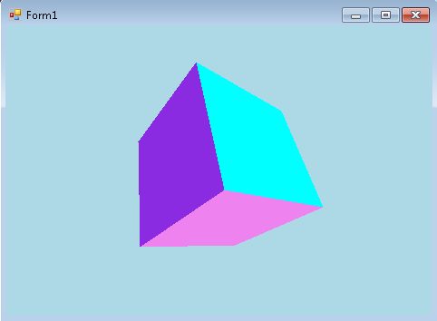

محمد احمد عبد الغنى ابراهيم( ترجمان عربى)

Mo.am86@yahoo.com

https://www.facebook.com/mohuomha.mo

تحميل السورس كود الخاص بالمثال

ستجد السورس ضمن مجموعة برامج اخرى على الرابط التالى

http://arabicturgeman.blogspot.com/

